Using the Debugger in VS .NET

To start, check out this portion of PowerPoint presentation about debugging:
http://www.cis.upenn.edu/~matuszek/cit591-2004/Lectures/11-error-messages.ppt#12

This may be a helpful tip for some of you while debugging. One approach to debugging is to step through your code statement by statement so you can see exactly what it is doing and when.

Try this...

Open up one of your projects/solutions. (It doesn't matter which one.)

Make sure you are in debug mode. You should be by default. This is debug mode looks like:

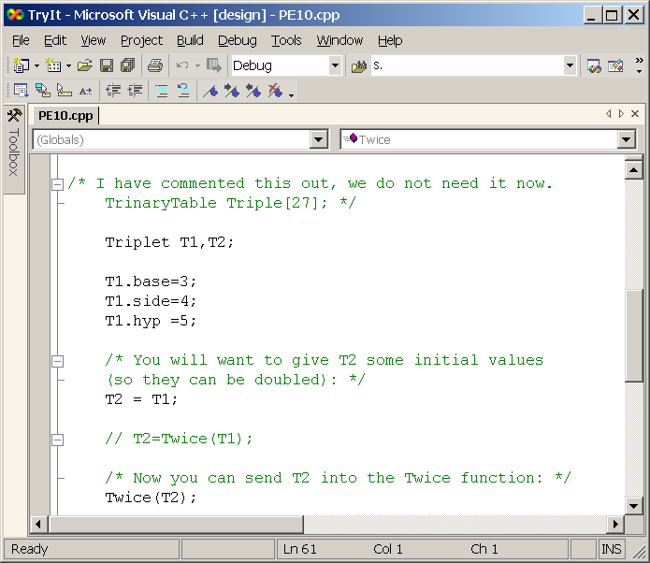

Left click to the left of almost any statement (not variable declarations) in your code on the vertical grey bar (see screenshot). You should see a red dot appear. You have just set a breakpoint at this line of code. A breakpoint is a location in your code where the code will stop executing while you debug your code.

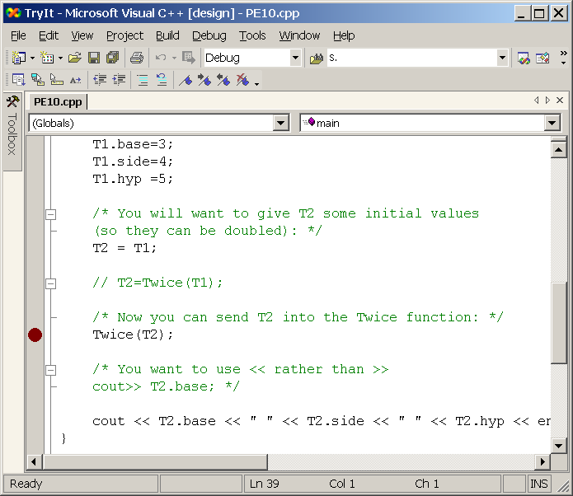

Compile and run your code.

When your code reaches the statement with the red dot you will see a yellow arrow appear over the red dot. You can then move your mouse over different aspects of the statement to see the values contained within different variables, etc. Note that in the example, my mouse was actually over the T2 in T2 = T1; line of code, one line above the line which was set as a breakpoint.

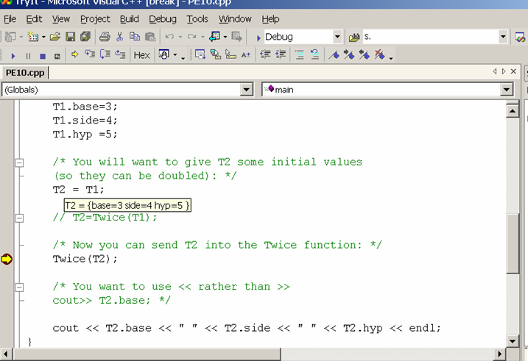

When you are satisfied that you are ready for the program to continue you can press F11 to move to the next statement or F9 to continue running as usual or until it reaches another break point.

When you are ready to remove your breakpoint just left click it again.

Here is a link to more information about setting breakpoints and what different indicators mean. It's pretty useful for the VS environment.

http://msdn.microsoft.com/en-us/library/ktf38f66.aspx

Check out this portion of PowerPoint presentation about debugging:
http://www.cis.upenn.edu/~matuszek/cit591-2004/Lectures/11-error-messages.ppt#12

